**Follow the instruction as below after clicking file “Git-2.13.2-64-bit.exe” from folder “Installation Files”**

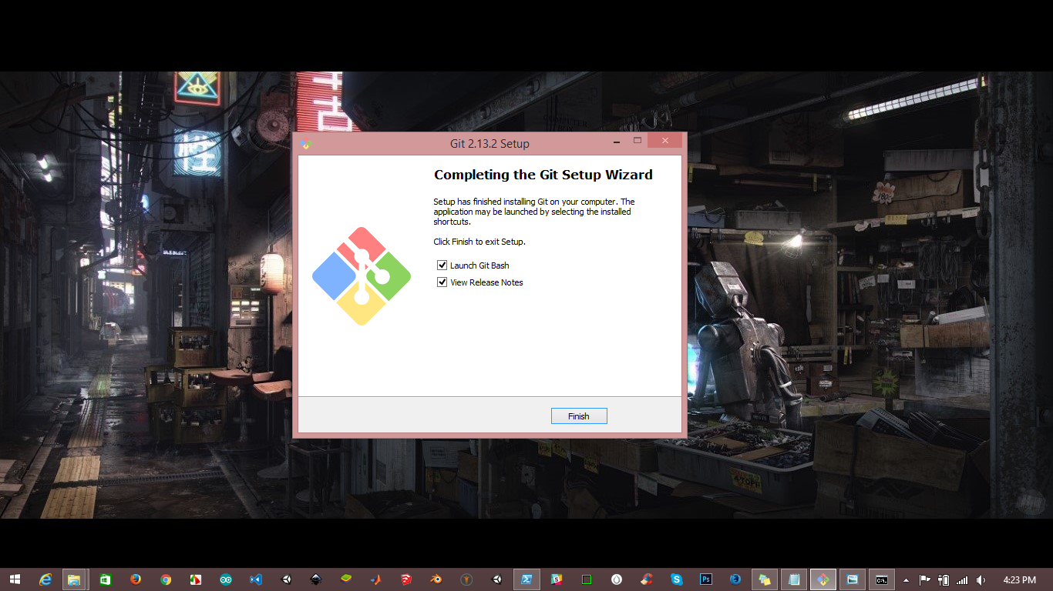

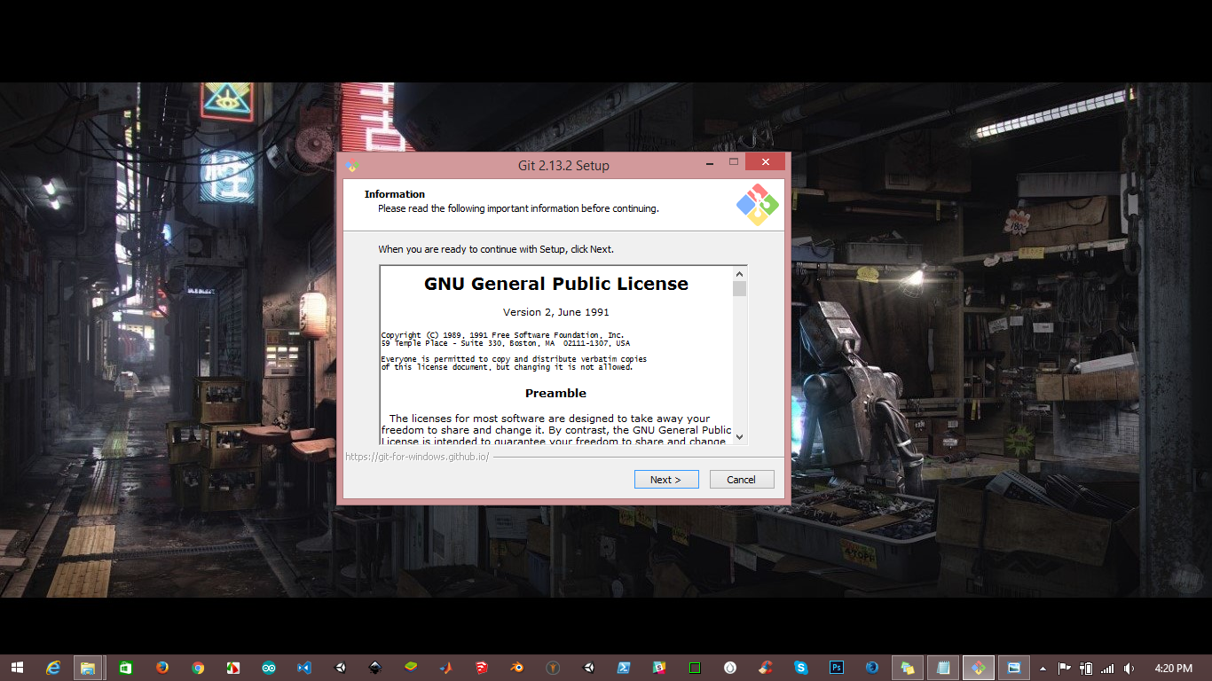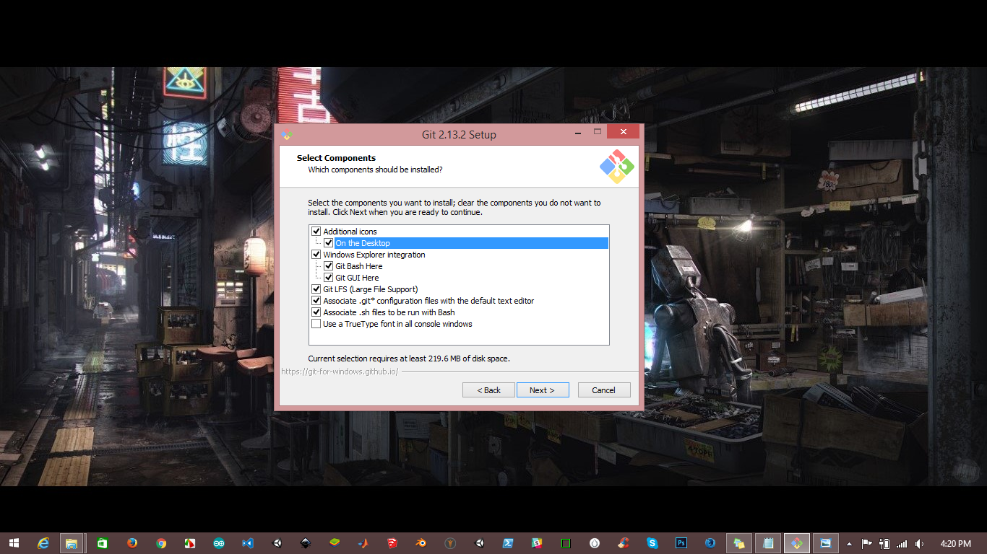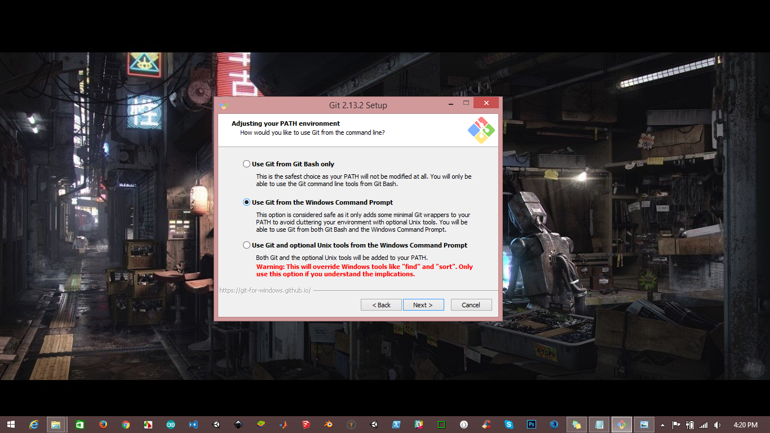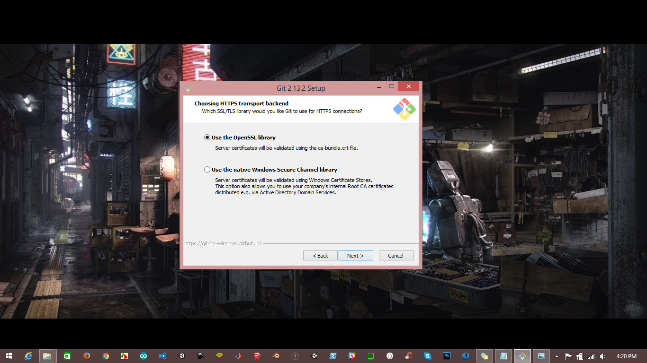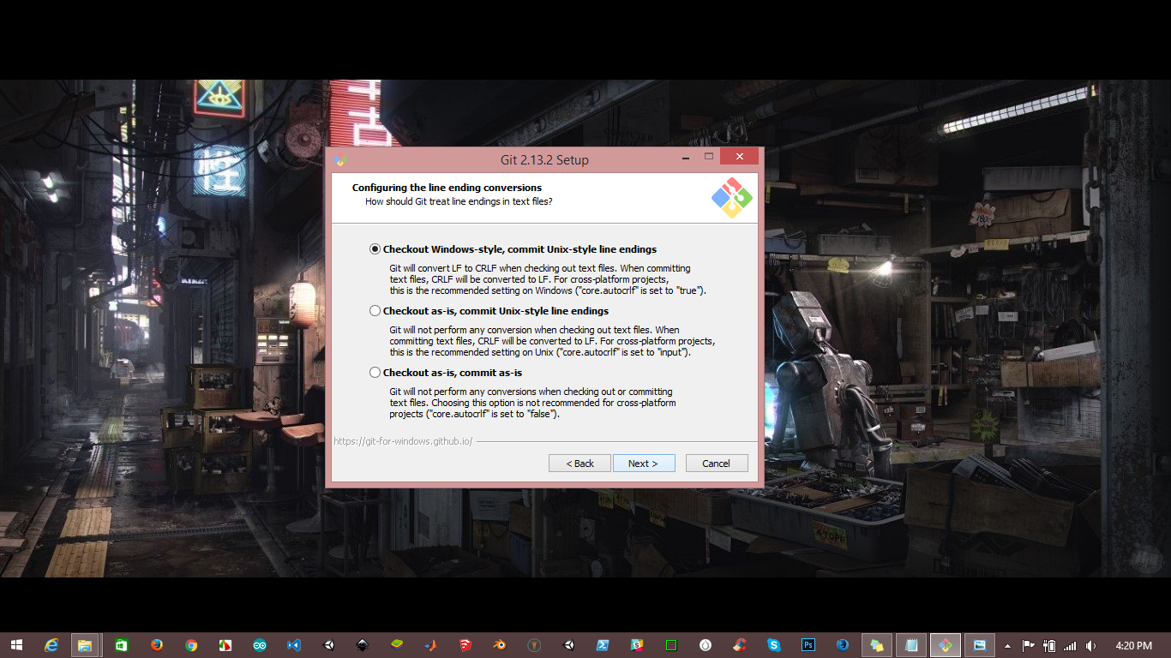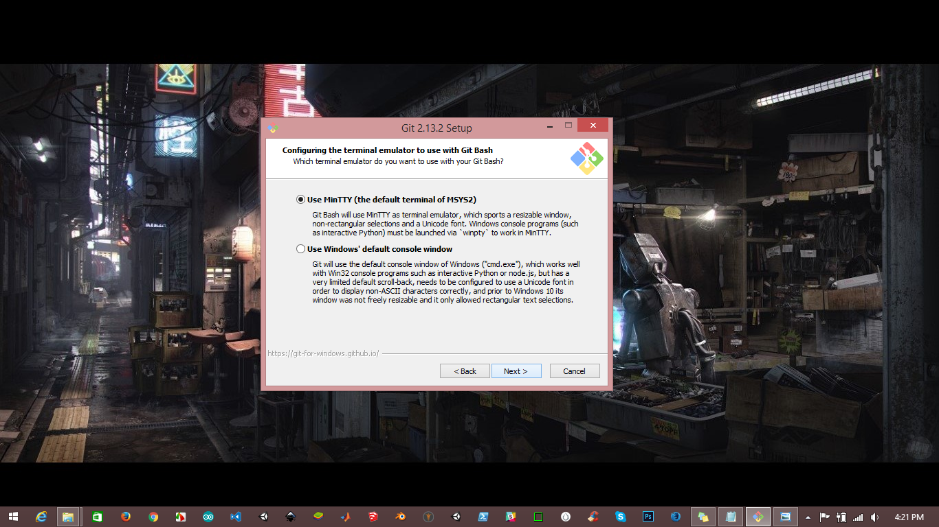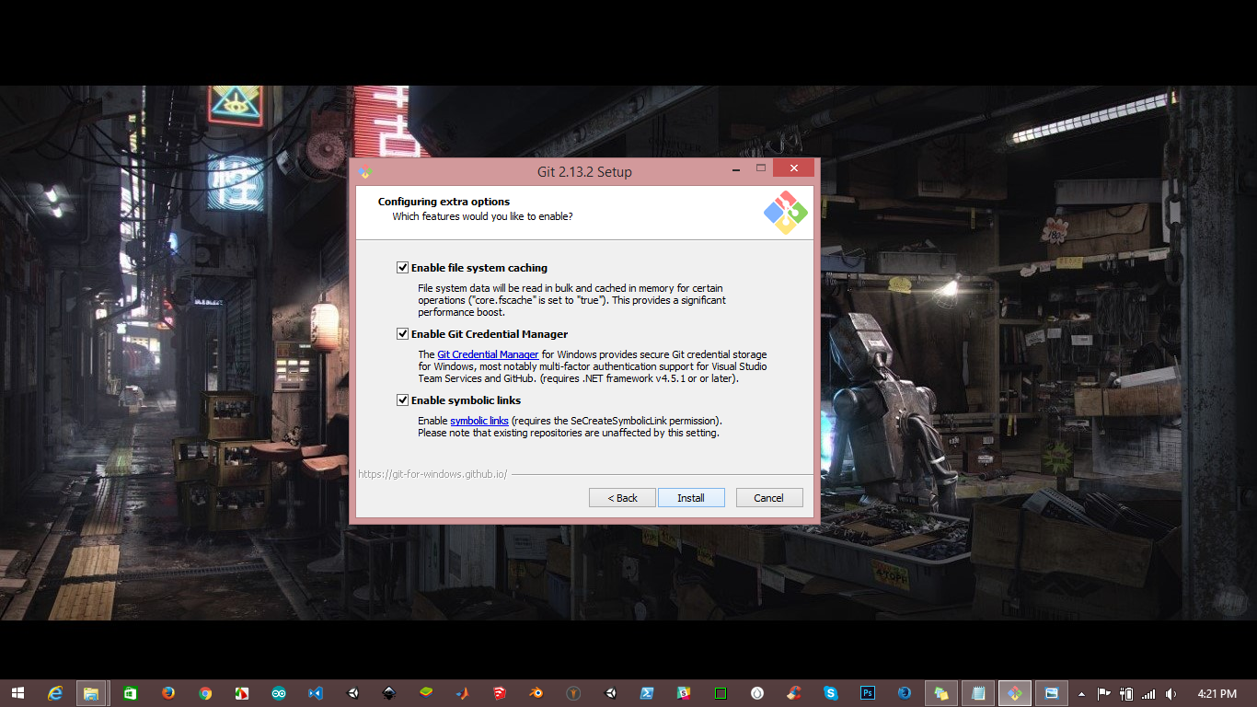

For Mac extract the disk image file “git-2.13.1-intel-universal-mavericks.dmg” from folder “Installation Files”

For linux user extract ‘tar.gz’/ tarball file “git-2.13.2.tar.gz” from folder “Installation Files”